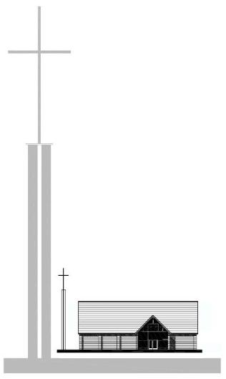
St. George’s Church - 2023
“As for me and my family, we will serve the LORD.”
Joshua 24 v 15 (NLT)

St. George’s Church - 2023
“As for me and my family, we will serve the LORD.”
Joshua 24 v 15 (NLT)

St. George’s Church - 2023
“As for me and my family, we will serve the LORD.”
Joshua 24 v 15 (NLT)

St. George’s Church - 2023
“As for me and my family, we will serve the LORD.”
Joshua 24 v 15 (NLT)

